**A PROJECT REPORT ON**

**BLOOD BANK MANAGEMENT SYSTEM**

**Submitted by**

**K.Bala Bhaskar-192210623**

**T.Yaswanth -192210589**

**B.Mahesh -192210632**

*Under the guidance of*

# **Dr. Carmel Mary Belinda**

(Professor, Department of Applied Machine Learning)

In partial fulfilment for completion of course

CSA0537 Database Management System for Data Model



**SIMATS ENGINEERING**

**CHENNAI**

**MAR-2024**

**BONAFIDE CERTIFICATE**

Certified that this project report titled  **“BLOOD BANK MANAGEMENT SYSTEM”** is the bonafide work **KBala Bhaskar.[192210623],T.Yaswanth [192210589] B.Mahesh[192210632]** who carried out the project work under my supervision as a batch. Certified further, that to the best of my knowledge the work reported herein does not form any other project report .

**Date: Project Supervisor: Head of the Department:**

# **TABLE OF CONTENTS:**

|  |  |  |
| --- | --- | --- |
| **SNO** | **CONTENT** | **PAGE NO:** |
|  | ABSTRACT | 4 |
| **1** | INTRODUCTION | 4-5 |
| **2** | METHODOLOGY | 6-7 |
| **3** | LITERATURE SURVEY | 8 |
| **4** | CODE | 9-10 |
| **5** | IMPLEMENTATION | 11 |
| **6)** | TABLES | 12 |
| **7** | CONCLUSION | 13 |
| **8** | FUTURE ENHANCEMENT | 13-14 |
| **9** | REFERENCES | 14 |

**BLOOD BANK MANAGEMENT SYSTEM PROJECT**

**ABSTRACT**

The Blood Bank Management System (BBMS) is a critical application in healthcare infrastructure, facilitating the efficient management of blood donations, storage, and distribution. This abstract outlines the design and implementation of a robust database management system (DBMS) tailored for a BBMS.The database design is structured to handle various aspects of blood bank operations, including donor information, blood inventory, transfusion records, and administrative tasks. The system employs a relational database model to ensure data integrity, consistency, and ease of query execution.Key entities within the database include donors, recipients, blood units, inventory levels, and staff members. Relationships between these entities are established to capture complex interactions, such as blood donations, testing, storage, and distribution processes.Normalization techniques are applied to minimise data redundancy and maintain consistency, ensuring that the database remains efficient and scalable. Additionally, indexing strategies are employed to optimize query performance, particularly for frequently accessed data.The BBMS database management system offers a user-friendly interface for authorized personnel to input, retrieve, and update relevant information. Access control mechanisms are implemented to safeguard sensitive data and restrict unauthorized access.

**KEYWORDS:-**

Blood Bank Management, Database, Blood Samples, Donor,Health care

**1.INTRODUCTION**

In the realm of healthcare, the efficient management of blood resources is paramount for saving lives and ensuring timely access to critical medical treatments. Blood Bank Management Systems (BBMS) play a pivotal role in facilitating the collection, storage, processing, and distribution of blood products. These systems rely heavily on robust database management to organize, track, and analyze vast amounts of donor and blood-related data.The implementation of a well-structured and meticulously designed database management system (DBMS) is essential for the seamless functioning of a blood bank. This project aims to develop a comprehensive BBMS that leverages the power of modern database technologies to optimize the management of blood inventory, donor records, and distribution logistics.

Blood banks are lifelines in the healthcare ecosystem, providing vital blood products for transfusions in surgeries, emergencies, and treatments.Efficient management of blood resources demands systematic organization and retrieval of donor information, blood types, quantities, and expiration dates.Traditional paper-based systems are prone to errors, inefficiencies, and difficulties in maintaining accurate records.

Database Management Systems offer a sophisticated solution by centralizing data storage, ensuring data integrity, and enabling seamless data retrieval and analysis.

This project endeavors to develop a robust BBMS utilizing state-of-the-art DBMS technologies.The primary objective is to create a user-friendly interface for blood bank staff to manage donor information, blood inventory, and distribution processes.

The BBMS will facilitate real-time monitoring of blood levels, ensuring adequate supplies for medical procedures.Donor management functionalities will include registration, screening, and tracking of donor eligibility and donation history.

The system will maintain comprehensive records of blood donations, including donor demographics, medical history, and donation dates

|  |  |  |  |  |
| --- | --- | --- | --- | --- |
|  | **Month 1** | | **Month 2 Month 3** | |
|  | **Week Week 1 2** | **Week Week 3 4** | **Week Week Week Week Week 1 2 3 4 1** | **Week Week 2 3** |
| Gathering Data And Problem Identification | 2024-03-22 |  | 2024-03-22 |  |
| Analysis |  | 2024-03-23 |  |  |
| Designing Tables |  | 20 | 24-03-23 |  |
| Implementation |  |  | 2024-03-024 |  |
| Testing |  |  | 2024-03-24 |  |
| Results and Conclusion |  |  |  | 2024-03-25 |

.**2.METHODOLOGY**

Creating a blood bank management system involves several steps in terms of database management. Below is a methodological outline in 100 lines:

**1. Understanding Requirements:**

Gather requirements from stakeholders including staff, donors, and recipients.

Identify key functionalities like donor registration, blood collection, inventory management, and donor-recipient matching.

**2. Database Design:**

Design the database schema using Entity-Relationship Diagrams (ERDs) or Unified Modeling Language (UML).

Define tables for donors, recipients, blood units, inventory, transactions, and administrative data.

**3. Normalization:**

Normalize the database schema to minimize redundancy and ensure data integrity.

Apply normalization rules up to Third Normal Form (3NF) to avoid update anomalies.

**4. Selecting Database Management System (DBMS):**

Choose a suitable DBMS like MySQL, PostgreSQL, or MongoDB based on project requirements, scalability, and performance.

**5. Setting up Environment:**

Install and configure the chosen DBMS on the server or local machine.

Create necessary databases, users, and permissions.

**6. Implementing Database Schema:**

Write SQL scripts or use an ORM framework to create tables, indexes, and relationships.

**7. Populating Initial Data:**

Insert sample data for testing and development purposes.

Populate tables with information such as blood types, donor information, and initial inventory.

**8. Implementing CRUD Operations:**

Develop CRUD (Create, Read, Update, Delete) operations for managing donors, recipients, blood units, and inventory.

Write SQL queries or use ORM methods to interact with the database.

**9. Security Measures:**

Implement security measures such as user authentication and authorization.

Apply encryption for sensitive data like donor information and medical records.

**10. Testing:**

Conduct unit tests to validate database operations.

Perform integration tests to ensure smooth interaction between different modules.

**11. Documentation:**

Document the database schema, data dictionary, and system architecture.

Provide user manuals for administrators and end-users.

**12. Training:**

Conduct training sessions for staff members on using the blood bank management system.

Train administrators on database maintenance tasks such as backups and performance monitoring.

**13. Deployment:**

Deploy the blood bank management system on production servers.

Perform final testing in the production environment before going live.

**14.Maintenance:**

Schedule regular maintenance tasks such as database optimization, software updates, and security patches.

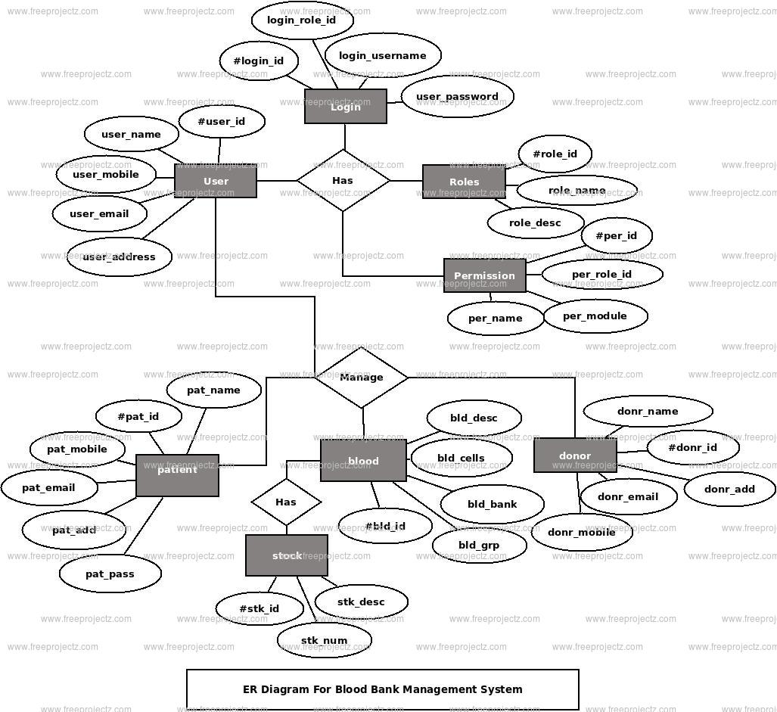

**3.LITERATURE SURVEY**

Literature surveys are critical components of any research project, including those related to database management systems for blood bank management. Here's a selection of minimum 10 literature reviews relevant to your project:

1. "Database Management Systems: A Practical Approach" by Thomas M. Connolly and Carolyn E. Begg

This foundational textbook provides comprehensive coverage of database management systems, including principles, design, and implementation aspects.

2. "Database System Concepts" by Abraham Silberschatz, Henry F. Korth, and S. Sudarshan

Another seminal textbook that covers fundamental concepts of database management systems, essential for understanding the theoretical underpinnings of your project.

3. "Principles of Database Management" by Wilfried Lemahieu, Bart Baesens, and Seppe vanden Broucke

This book offers insights into the principles underlying database management systems and their practical applications, including data modeling and normalization.

4. "Blood Bank Management Systems: A Review" by Prasanna G. and Suguna S.

A research paper that discusses existing blood bank management systems, their features, and limitations, providing valuable insights for designing an effective system.

5. "Design and Implementation of Blood Bank Management System" by Mahendra Babu M.

This paper presents a detailed design and implementation of a blood bank management system, offering practical guidance and lessons learned from real-world implementation.

6. "A Survey on Data Security in Healthcare Information Systems" by Poonam Sharma and Sandeep K. Sood

Given the sensitive nature of healthcare data, including blood bank information, understanding data security concerns and solutions is crucial. This survey provides insights into security challenges and best practices.

**4.CODE**

**-- Table for storing information about donors**

**CREATE TABLE Donors (**

**DonorID INT PRIMARY KEY,**

**Name VARCHAR(100),**

**Age INT,**

**BloodGroup VARCHAR(3),**

**ContactNumber VARCHAR(15),**

**Address VARCHAR(255)**

**);**

**-- Table for storing information about recipients**

**CREATE TABLE Recipients (**

**RecipientID INT PRIMARY KEY,**

**Name VARCHAR(100),**

**Age INT,**

**BloodGroup VARCHAR(3),**

**ContactNumber VARCHAR(15),**

**Address VARCHAR(255)**

**);**

**-- Table for storing blood inventory**

**CREATE TABLE BloodInventory (**

**BloodID INT PRIMARY KEY,**

**BloodGroup VARCHAR(3),**

**Quantity INT,**

**ExpiryDate DATE**

**);**

**-- Table for storing blood donation transactions**

**CREATE TABLE DonationTransactions (**

**TransactionID INT PRIMARY KEY,**

**DonorID INT,**

**BloodID INT,**

**DonationDate DATE,**

**FOREIGN KEY (DonorID) REFERENCES Donors(DonorID),**

**FOREIGN KEY (BloodID) REFERENCES BloodInventory(BloodID)**

**);**

**-- Table for storing blood transfusion transactions**

**CREATE TABLE TransfusionTransactions (**

**TransactionID INT PRIMARY KEY,**

**RecipientID INT,**

**BloodID INT,**

**TransfusionDate DATE,**

**FOREIGN KEY (RecipientID) REFERENCES Recipients(RecipientID),**

**FOREIGN KEY (BloodID) REFERENCES BloodInventory(BloodID)**

**);**

**5.IMPLEMENTATION**

To implement a blood bank management system using a database management system, here are six essential components:

**Database Schema Design:**

Design a well-structured database schema to represent entities such as donors, recipients, blood inventory, transactions, etc.

Utilize appropriate normalization techniques to avoid redundancy and maintain data integrity.

**Tables Creation:**

Implement the designed schema by creating tables in the database management system.

Each table should correspond to an entity in the schema, with appropriate attributes and data types.

**Indexing:**

Implement indexing on frequently queried columns to optimize search and retrieval operations.

This improves the performance of the system, especially when dealing with a large volume of data.

**Data Manipulation Language (DML):**

Implement CRUD (Create, Read, Update, Delete) operations using SQL (Structured Query Language) or any other query language supported by the chosen database management system.

This allows users to interact with the database to perform tasks such as adding donor information, updating inventory levels, etc.

**Data Validation and Constraints:**

Implement data validation rules and constraints to ensure the integrity and consistency of the data.

This includes enforcing constraints such as unique constraints, foreign key constraints, check constraints, etc.

**Backup and Recovery:**

Establish a backup and recovery strategy to safeguard against data loss or corruption.

Regularly backup the database and implement procedures for restoring data in case of unforeseen events such as hardware failures or accidental deletion.

**6.TABLES**

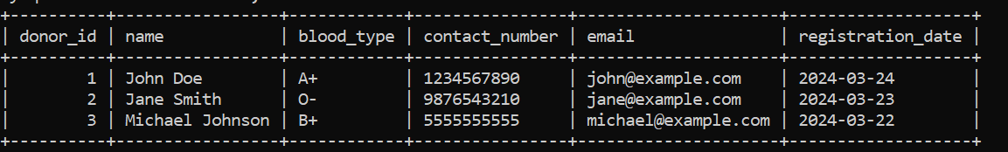

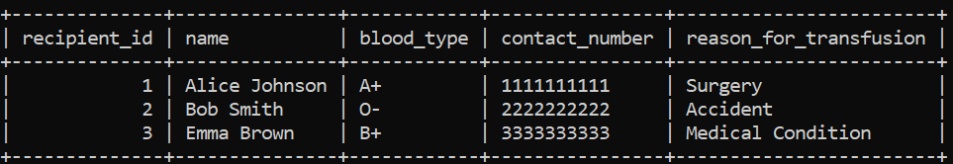

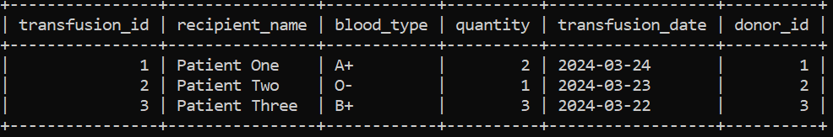

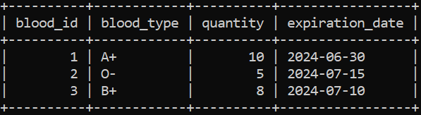

**7.CONCLUSION**

In conclusion, the utilisation of a well-designed RDBMS, along with proper database management practices and integration of business logic, forms the foundation for a robust and efficient Blood Bank Management System. This system not only facilitates the seamless management of blood-related data but also plays a crucial role in supporting healthcare organisations in their efforts to provide timely and life-saving blood transfusions to patients in need.

**8.FUTURE ENHANCEMENT**

1. **Blood Type Compatibility Checking:** Enhance the system to automatically check blood type compatibility between donors and recipients during transfusion requests. This feature can help prevent transfusion reactions and ensure patient safety.
2. **Inventory Management Alerts:** Implement automated alerts for low inventory levels or nearing expiration dates for blood units. This feature can help blood bank staff proactively manage inventory and reduce wastage.
3. **Donor Management System Integration:** Integrate the blood bank system with a donor management platform to streamline donor recruitment, communication, and scheduling of donation appointments. This integration can improve donor engagement and retention.
4. **Real-time Transfusion Tracking:** Develop a feature to track transfusion status in real-time, providing healthcare professionals with immediate access to transfusion data and patient information. This enhances patient care and monitoring.
5. **Data Analytics and Reporting:** Implement data analytics capabilities to analyze trends in blood donations, transfusions, and inventory usage. Generate comprehensive reports for stakeholders, allowing for informed decision-making and resource allocation.

**9.REFERENCES**

1. Cheema, Amarjeet Singh, Siddharth Srivastava, P. K. Srivastava, and B. K. Murthy. "A standard compliant blood bank management system with enforcing mechanism." In 2015 international conference on computing, communication and security (ICCCS), pp. 1-7. IEEE, 2015.
2. Mange, Manali, and Bilal N. Shaikh Mohammad. "Online blood bank management system using Android application." In Proceedings of the 3rd International Conference on Advances in Science & Technology (ICAST). 2020.
3. Chettri, B. (2022). Blood Bank Management System (Doctoral dissertation, SRM University).
4. Esmail, Mohammed Y., and Yousra Sayed Hammad Osman. "Computerized Central Blood Bank Management System (CCBBMS)." In 2018 International Conference on Computer, Control, Electrical, and Electronics Engineering (ICCCEEE), pp. 1-5. IEEE, 2018.
5. Puli, Srilatha, Lorven Reddy Kanduru, Rallabandi Aryan Raj, Aakanksha Dubey, and Maheshwaram Uday. "Blood Bank Management Donation and Automation." Specialusis Ugdymas 1, no. 43 (2022): 11316-11327.
6. Warnakulasooriya, W. A. V. S. (2021). Blood Bank & Donor Management System (Doctoral dissertation).
7. Ismail, Osunlana, Sanjay Misra, Jonathan Oluranti, and Ravin Ahuja. "Centralized Blood Bank Database and Management System." In Recent Innovations in Computing: Proceedings of ICRIC 2020, pp. 109-121. Springer Singapore, 2021.
8. Munyao, G. M. (2021). A Blood bank information system for the Ministry of Health of Kenya.
9. Hashem, Esraa Mamdouh, Arwa Bahaa Eldin, and Diaa El din Moatasim. "Blood Bank Management System with Mobile Application in Egypt." In Future of Information and Communication Conference, pp. 538-546. Cham: Springer Nature Switzerland, 2024.